Paper Game
Tonia Sanzo

Summary

Paper Game is a user interface intended to facilitate running and playing fictional tabletop role playing game’s. Paper Game will provide a user-friendly GUI while giving user’s complete freedom over the content, story, and event’s that transpire within the game. Paper Game will feature creature creation, weapon creation, armor creation, consumable creation, and combat map creation. Paper Game will have two types of user’s “Dungeon Master’s” and “Player’s.” User’s communicate via Peer-to-Peer networking. Objects created within the Game will be persistently saved to their computer’s. The entire game will be managed via a user-friendly guided user interface.

Technical Aspects

Paper Game is written in Java (JDK 11.0.1). Paper Game uses the external library JavaFX for GUI development. The networking is Peer-to-Peer and done with Sliding Window Protocol built on top of UDP.

Wire Frames
Figure 1, illustrates the start-up screen, the user will have the option to choose between playing as a “Player” or playing as a “Dungeon Master.”
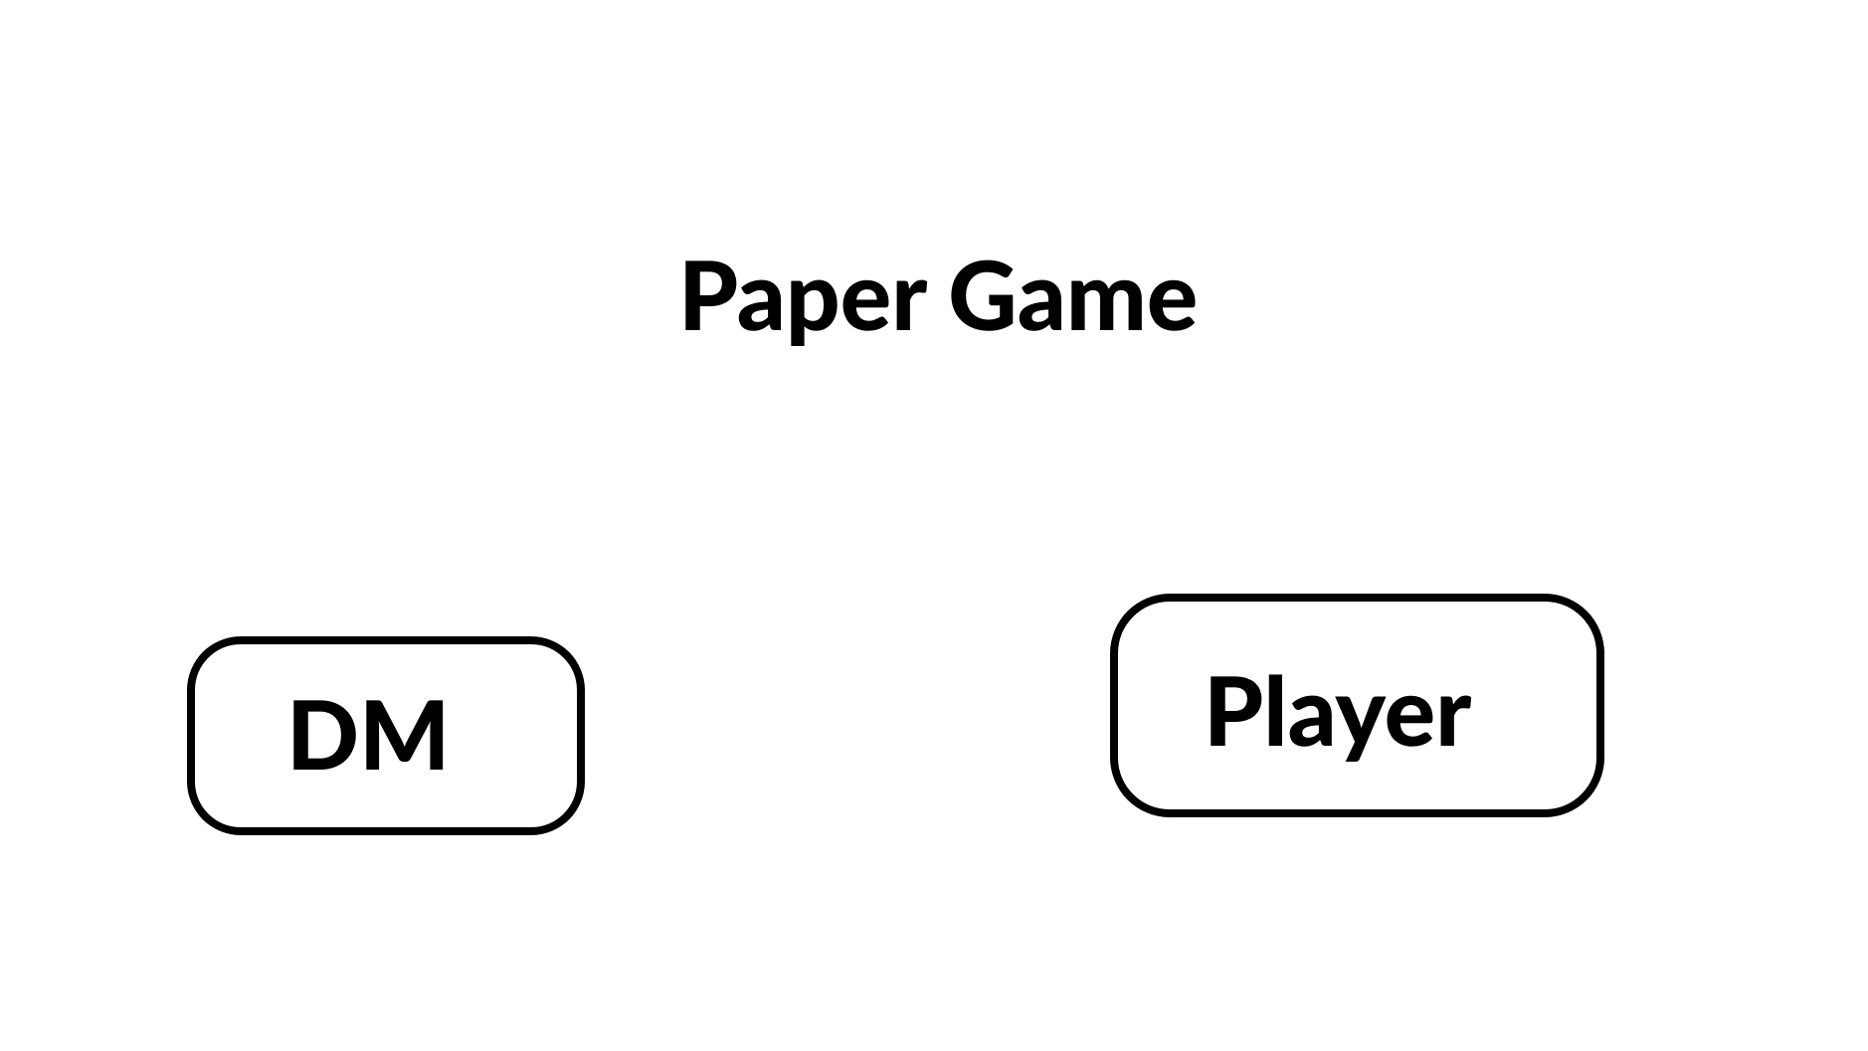
Figure 1 (above)

Figure 2, Demonstrates the player start-up screen, the user is given the option between creating a new character or loading a previously created character from here. Also the IP address of the DM is submitted here to initially join the room.
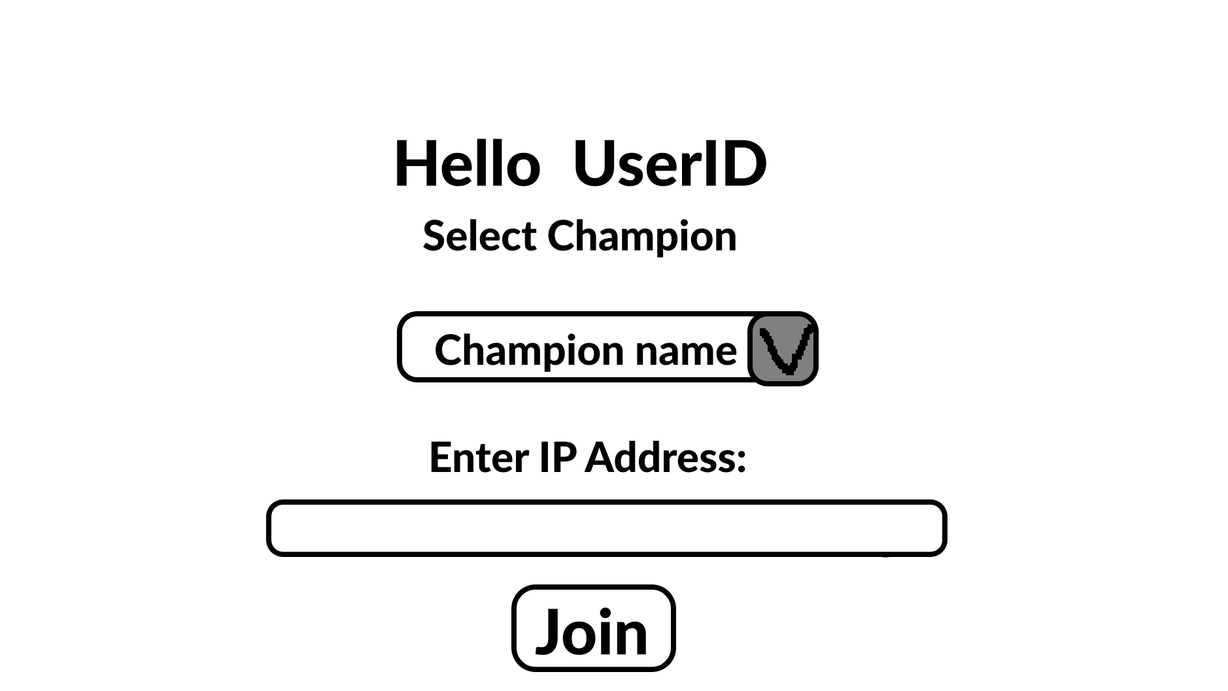
Figure 2 (above)
Figure 3, The character creation screen.
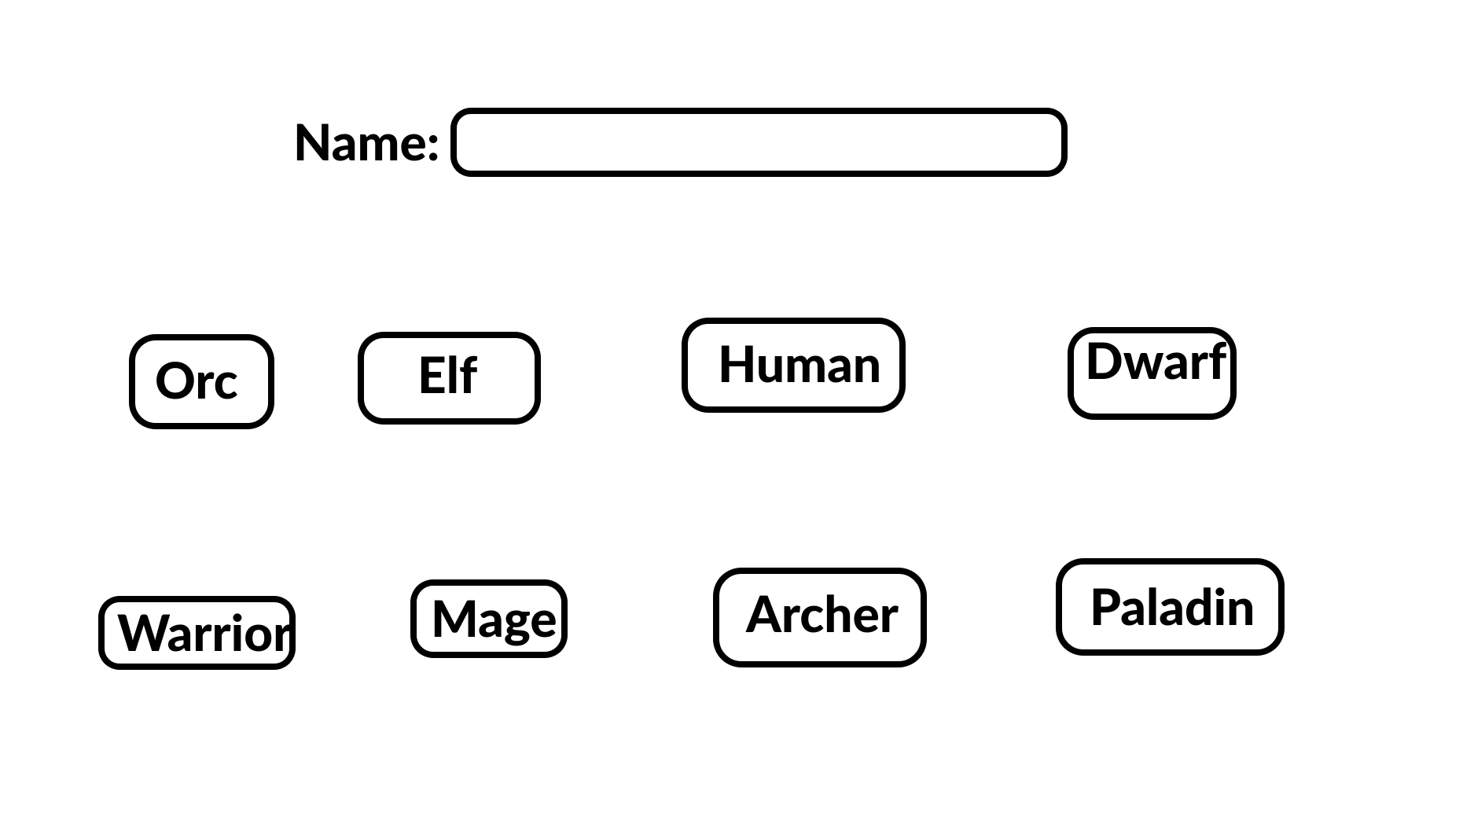
Figure 3 (above)

Figure 4, The player master page, containing information about the current champion being played. Buttons to view the champion’s inventory, initiate trade, and an options button. The gray area labeled Player-Fluid_SubSection, will change dynamically based on the state of the game.
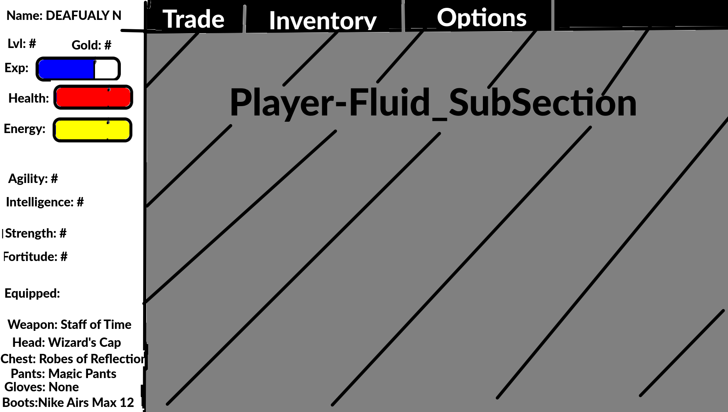

Figure 4 (above)
Figure 5, illustrates how the Player-Fluid_SubSection will appear when the user clicks the Inventory button. From here the player will be able to equip weapons and armor, as well as use consumables.
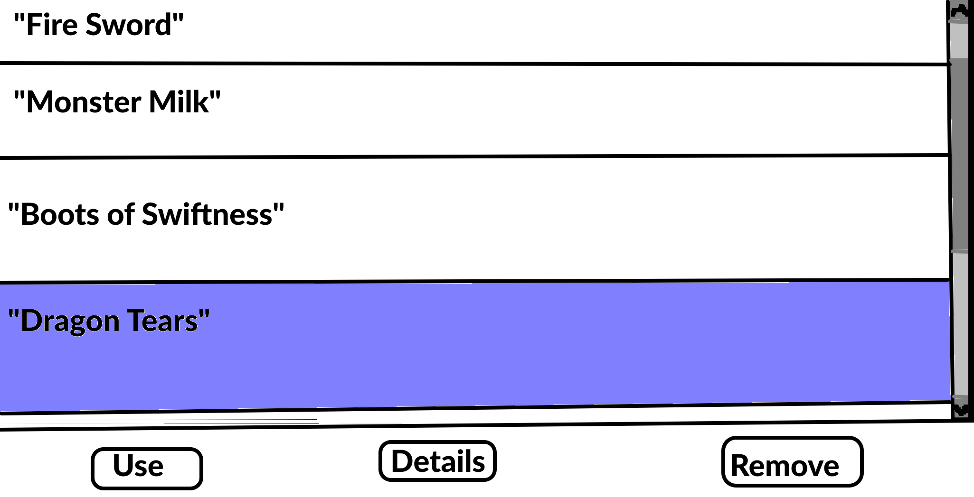
Figure 5 (above)

Figure 6, The Dungeon Master start up screen, the rooms IP address is displayed and it will display the user’s who joined the room. Start begins the game sessions for everyone
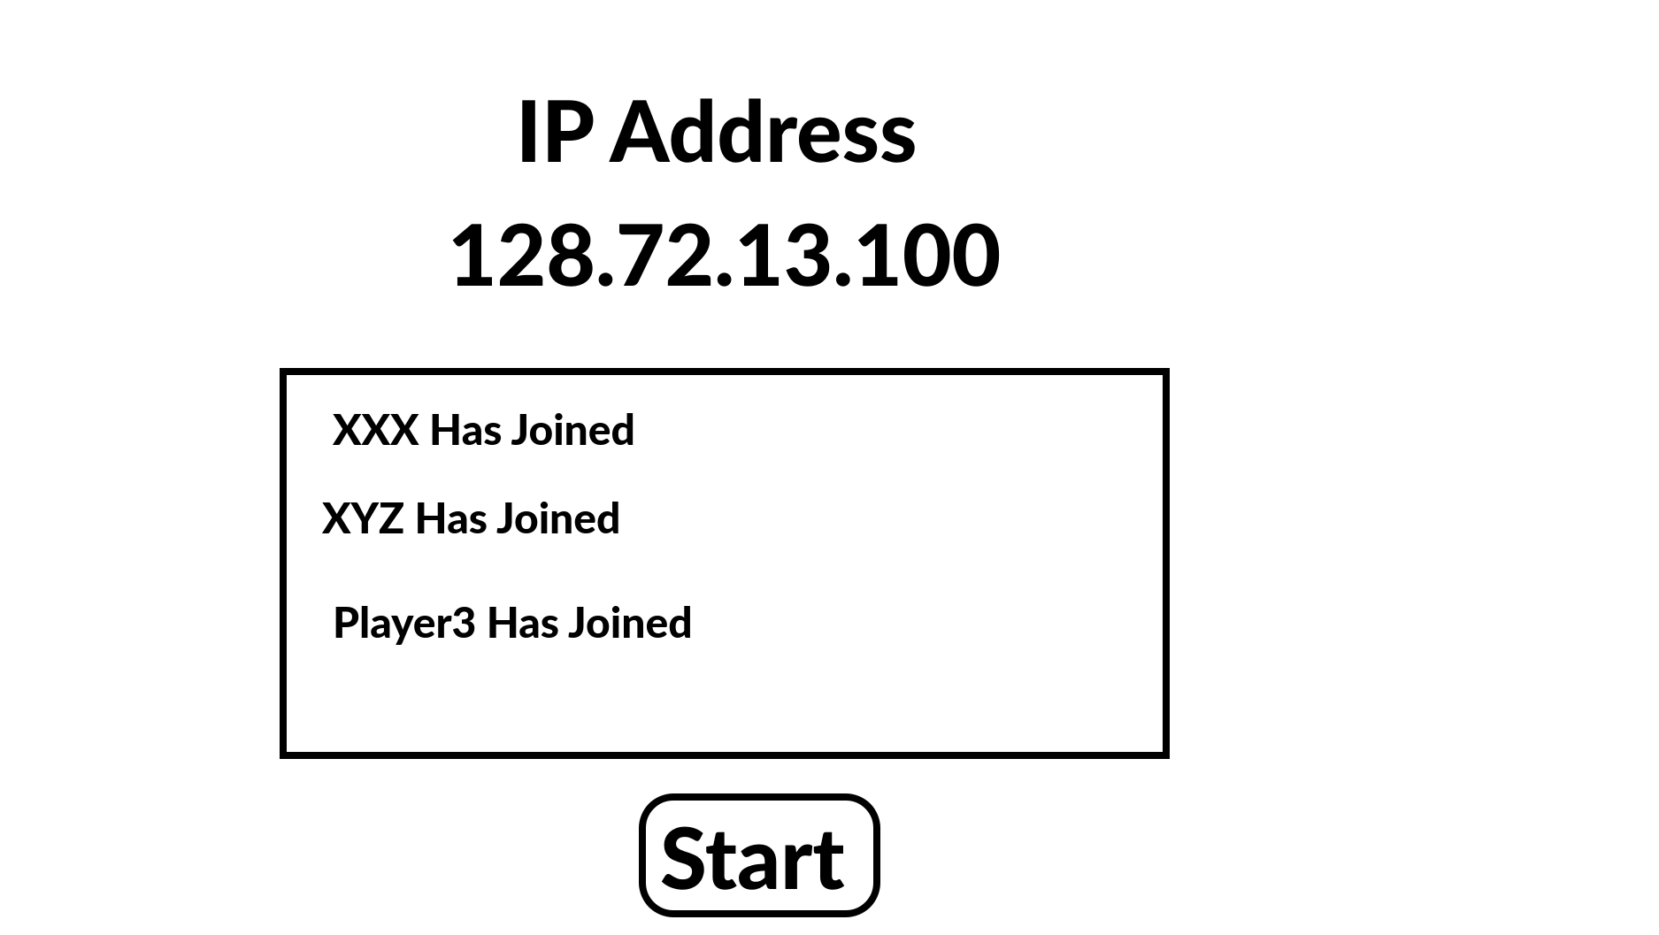
Figure 6 (above)
Figure 7, Dungeon Master main page, this is where the interface is used. The Dungeon Master will have a large range of options to decide between from object creation, searching, and sending, displayed in the top bar. To starting combat encounters, prompting a skill check, hosting a trade negotiation, to interacting with and changing the stats of any given user.
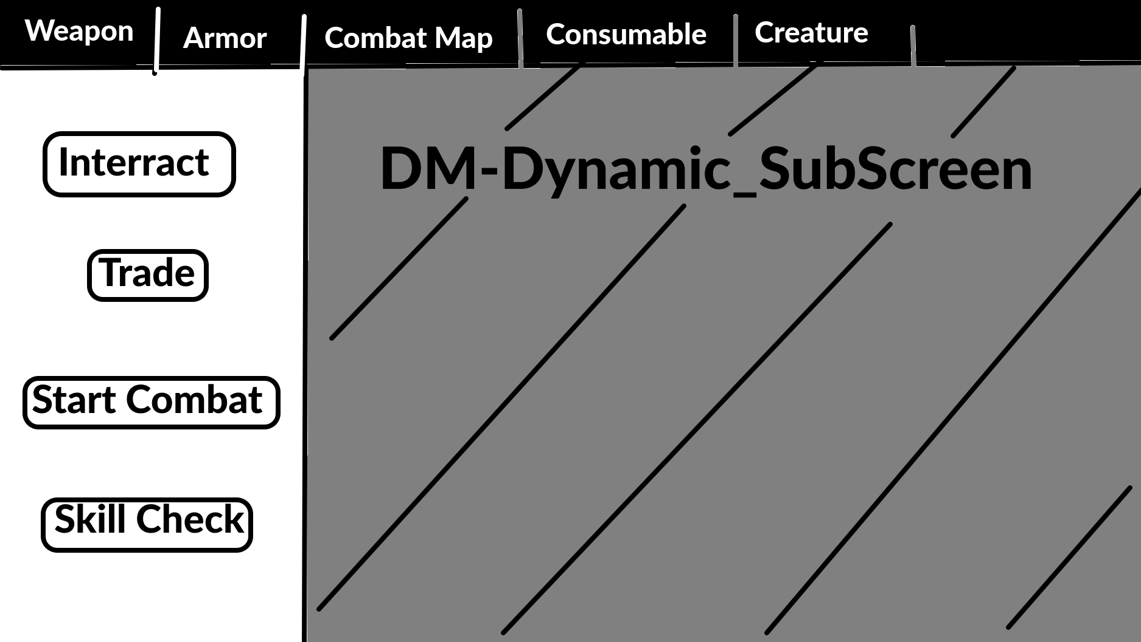
Figure 7 (above)

Figure 8, A representation of the Weapon, Armor, Consumable, and Creature sub screens. Creation, Deletion, Editing, and Information on a particular object is given here. As well as being able to query for any object
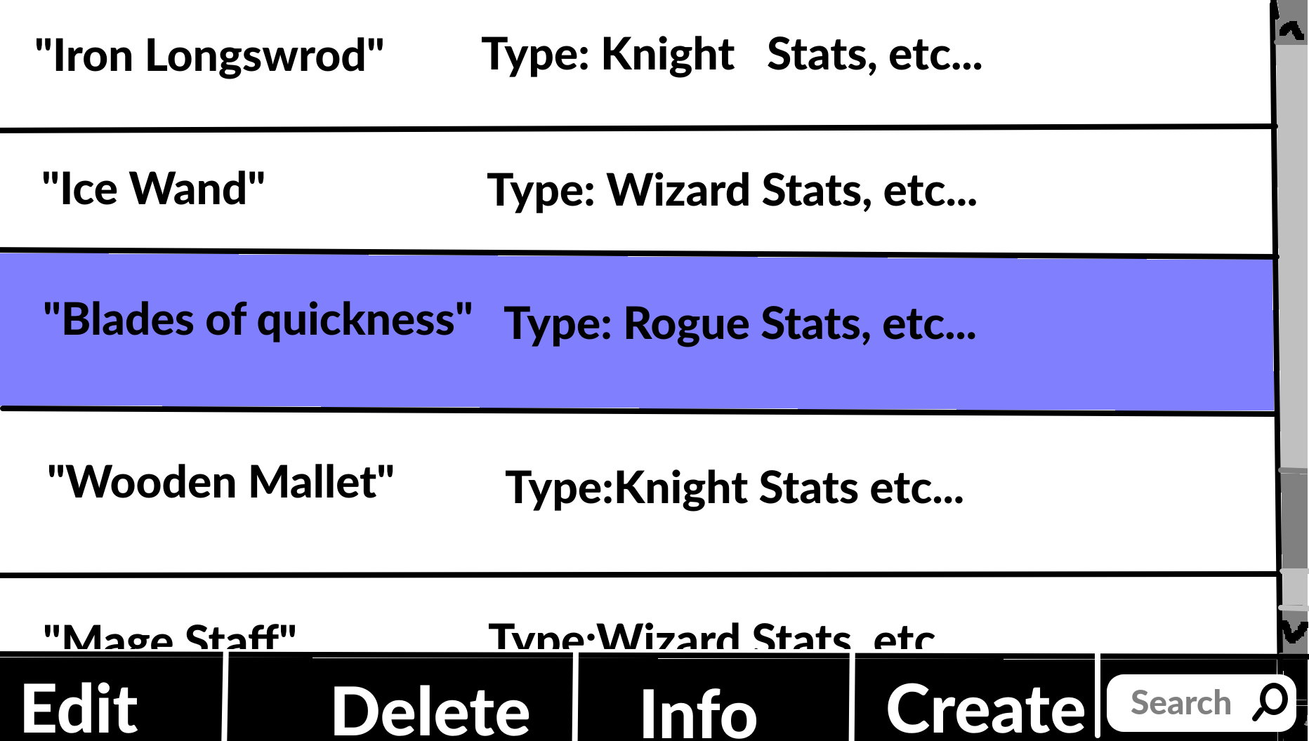

Figure 8 (above)
Figure 9, Skill check screen, the Dungeon Master decide what skill to check, which dice to check the skill with, and which champion to apply the skill check too.
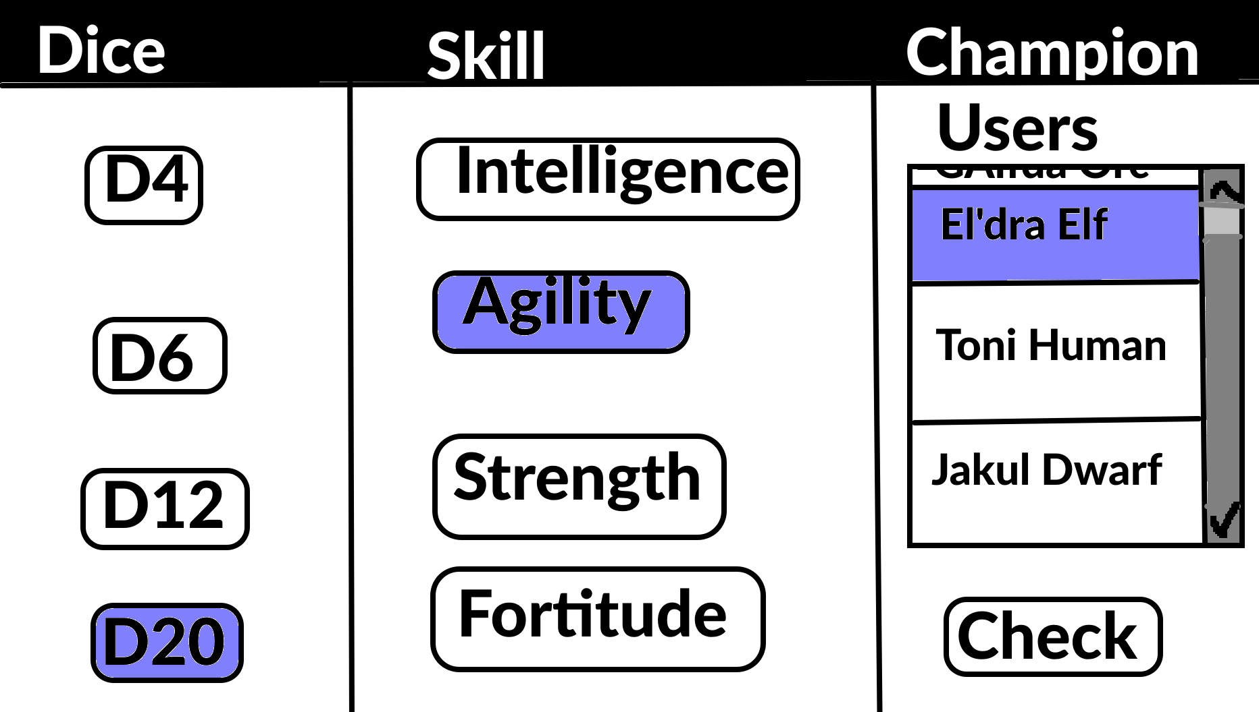
Figure 9 (above)

Figure 10, Illustrated below is the Combat Map option screen, you can create, edit, and view the details of the combat map. Only available to the Dungeon Master.
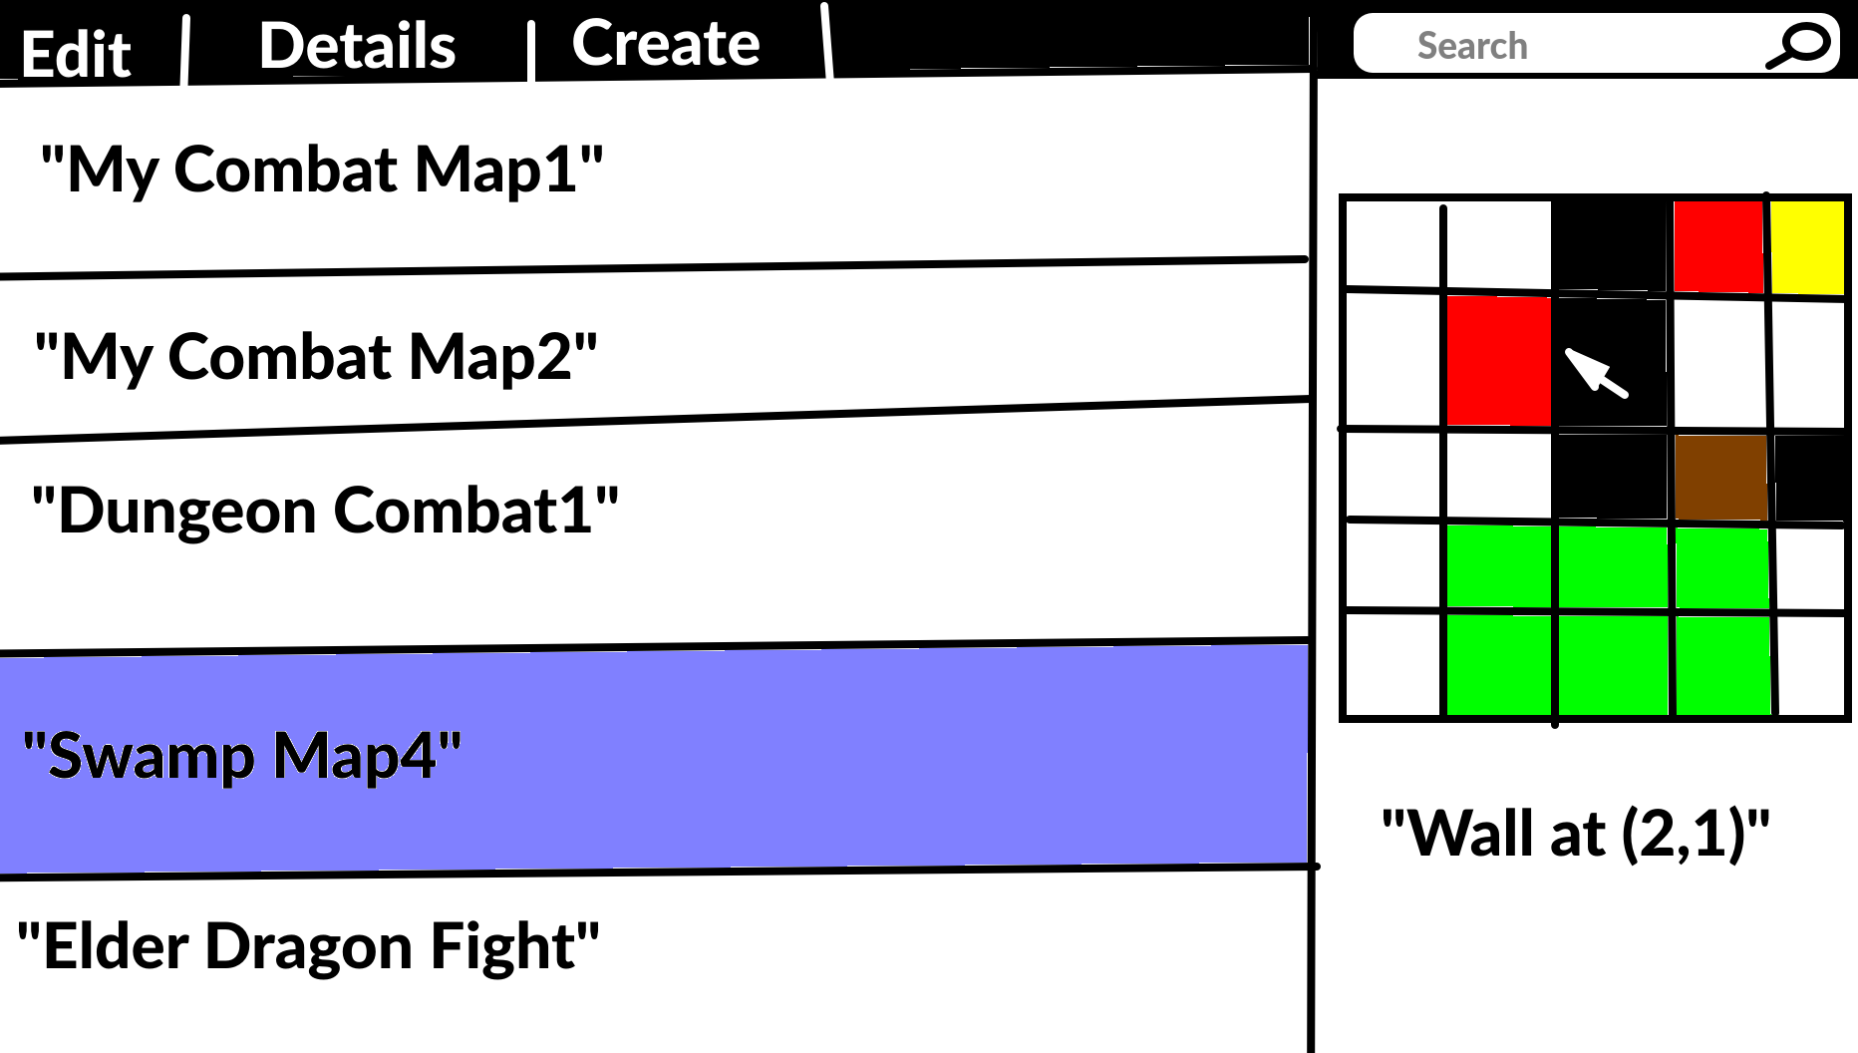
Figure 10 (above)
Figure 11, Display’s how the trade screen will be ran. Choosing from the items you can on the left hand side, you decide what you want to offer and receive. The Dungeon Master’s items will be any item, with any quantity.
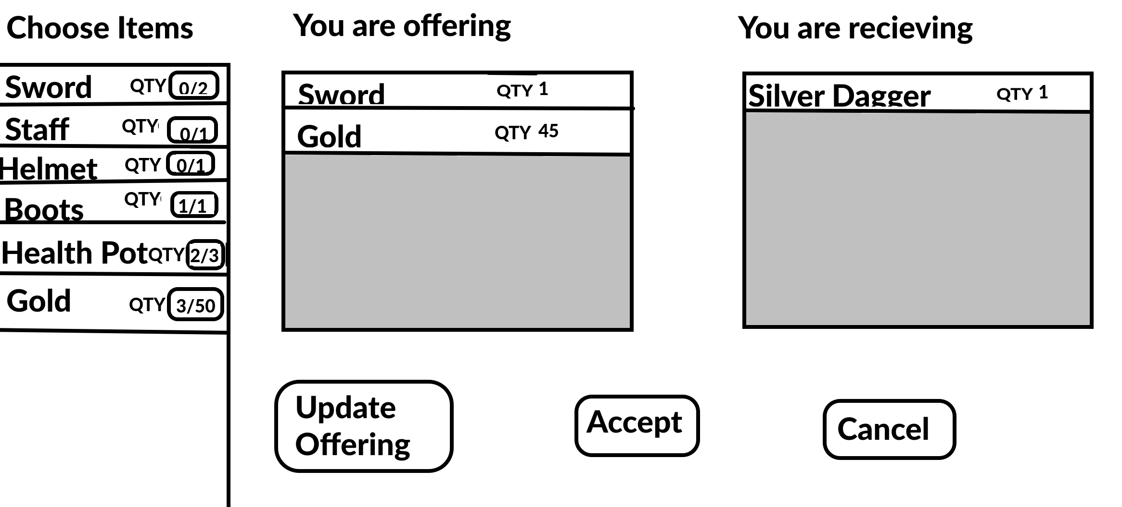
Figure 11 (above)

